Ch 14
Damping off
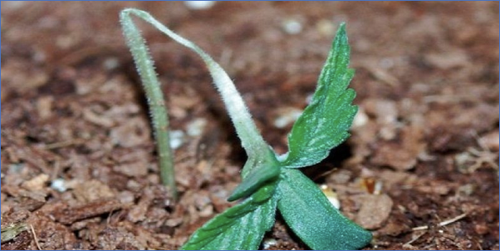
Figure 14.1. Cannabis plant that has been infected with a damping off causing fungus.

Taxonomy

Kingdom: | Fungi | Fungi | Fungi | Chromista | Fungi
Phylum: | Basidiomycota | Ascomycota | Ascomycota | Heterokontophyta | Ascomycota
Class: | Agaricomycetes | Leotiomycetes | Sordariomycetes | Oomycota | Dothideomycetes
Order: | Cantharellales | Helotiales | Hypocreales | Peronosporales | Botryosphaeriales
Family: | Ceratobasidiaceae | Sclerotiniaceae | Nectriaceae | Pythiaceae | Botryosphaeriaceae
Genus: | Rhizoctonia | Botrytis | Fusarium | Pythium | Macrophomina
Species: | R. solani | cinerea | F. solani, F. oxysporum, F. sulphurem, F. avenaceum, F. graminearum. | P. aphanidermatum; P. ultimum. | M. phaseolina

Introduction
Damping off, often incorrectly called dampening off, is common on many horticultural plants. The term is used to classify diseases caused by multiple fungi that mainly affect plants in the seedling stage. Typically, damping off (DO) kills the plant before or shortly after the seed germinates, but can also occur on unrooted or newly rooted cuttings.
Plants that are infected with these fungi may germinate and emerge from the soil but within a few days they are weakened by the fungus growing on the stem or root tissue. Often, the pathogen will infect the stem right where it emerges from the soil (post-emergent). This results in plants that are wilted and falling over. However, DO pathogens can also cause pre-emergent disease as well, preventing seedling from ever emerging from the soil (Neher et al. 1987).
Once you see that a plant has fallen victim to damping off, it is typically too late to act. Plants that are infected with these fungi usually will be too damaged to recover after the symptoms are observed. The same damping off fungi can infect a number of host plants, making the fungi that cause DO generalists. This is similar to the bud rot causing fungus, B. cinerea, which itself can cause damping off in seedlings (Darvas et al. 1978).
Thankfully, this disease is mainly restricted to seedlings or young plants. As seedlings mature they express more resistance traits, including production of secondary metabolites and increased structural defence. Damping off is a particularly high risk for hemp fields, where farmers are directly sowing a large number of seeds into soil (Gibson 1956). If the soil is too cold and wet or other conditions favorable for the fungus, the pathogen can grow and infect the farmers' hard work (Yitbarek et al. 1988). Spores of the fungus could be waiting in the medium that the seed is planted into, on the seed coat itself, or blown in by the wind.
The presence of the pathogen in a particular soil does not necessarily mean that plants will get infected, although some researchers have noted that inoculum levels can be directly correlated to infection rate (Yitbarek et al. 1988). Neher et al. noticed that environment, virulence of pathogens, and the susceptibility of the host all influence disease severity and mortality rate. Researchers have also found that the diversity of the microbial community in soils can have a significant impact on decreasing the infection rate (Ross et al. 2019). Perhaps microbial consortias will produce more effective biocontrol agents (BCA) in the future than single-species products. Microbial teas and compost applications can increase microbial diversity, but are unselective for species. Single-species products containing known antagonists may be more effective when combined.
Although fungi can cause this disease, it can also be caused by Oomycetes, or the water molds, which are not true fungi. Water molds were originally classified as fungi based on fungus-like morphology, but were reclassified according to ancestry as protists of the phylum Heterokonta. This places them as close relatives of photosynthetic algae. Most water molds behave as parasites or pathogens. As mentioned previously, the great potato famine of Ireland was caused by the water mold of the genus Phytophthora. Interestingly, no species of Phytophthora is known to infect Cannabis, including the generalist P. cinnamomi (at least it has not yet been identified to do so). In fact, Cannabis is even recommended as a rotation crop for the purpose of controlling for Pytopthora (Isreal 1981). Pythium, on the other hand, is an Oomycete that may be the most common cause damping off in Cannabis.
A distinguishing factor between water molds and fungi are that water molds have mobile asexual zoospores that can actively disperse in water. Therefore damp, water-logged soils create the optimal environment for these pathogens to grow and flourish, especially if a susceptible host is planted nearby.

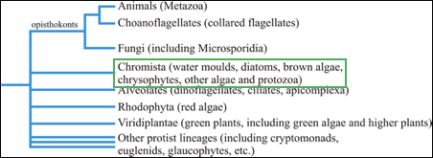
Figure 14.2. Phylogenetic tree showing the relationship between water molds, fungi, and animals.

Biology & Life cycle
Oomycota
Water molds share some superficial similarities with fungi, including the filamentous growth and presence of cell walls. The materials that comprise the cell wall among Oomycetes are cellulose and beta-glucans, rather than chitin as in fungi. Also, water mold spores (zoospores) have two flagella to help them move and navigate through liquid substrates. The only true fungi that possess flagella are the chytrid zoospores that have a singular posterior flagellum. Oomycete hyphae are coenocytic, or aseptate. This is most likely why some people tell farmers when looking at soil or root samples under the microscope to beware of hyphae without septa. However, not all aseptate fungi are bad (the mycorrhizal Glomeromycota for instance, as well as many harmless saprophytic Zygomycota), and not all fungi with septa are good (most fungal pathogens are septate). Though these organisms are related to algae, they have lost their ability to perform photosynthesis.
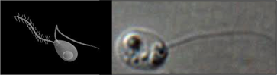
Figure 14.3. Left: Oomycete zoospore with 2 flagella. Right: Chytrid zoospore with single posterior flagellum.

Oomycetes like Pythium have a complex lifecycle with different forms and growth patterns. Water mold’s life begins, like a fungus, with a spore. This spore begins to grow when it lands on a suitable growth substrate, such as plant tissue. The spore will germinate and begin to grow hyphae. Like fungi, they access host tissue by developing an appressorium, releasing extracellular enzymes to assist in damaging and entering host tissue. Hyphae invade host tissue and siphon nutrients to the oomycete.
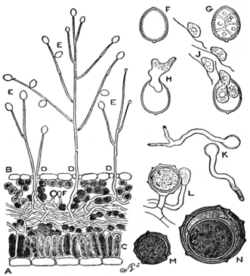
Figure 14.4. A) Leaf cross-section of Pytopthora infestans hyphae growing through leaf tissue, B) P. infestans sporophores sprouting through stomata. C) Palisade mesophyll layer of leaf D) Under (abaxial) side of leaf E) Sporangia hold zoospores F,G,H) Sporangium development J) Mobile zoospores K) Germinating zoospores L) Antheridium and Oogonium fusion M,N) Development of oospore
Water molds are typically transmitted in water and have even been found in some irrigation waters (Ali-Shtayeh et al. 1991). Therefore eliminating any stagnant or still water in or near fields may help reduce harboring pathogens in close proximity to crops. Once a field is infected, zoospores of the fungus are able to encyst in a dormant state. When the environment becomes favorable again, the cyst can germinate and infect plants. This is why once soil has been contaminated with these organisms, it can be difficult to remediate.

Table 14.1. Comparison of some characteristics of Oomycota and true fungi.
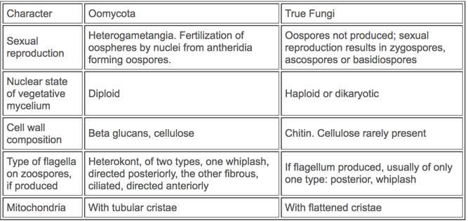

Fungi
A wide range of fungal species cause the damping off disease across various species of plants. Many of these diverse fungal pathogens can infect Cannabis plants. Of the species of fungi that act as generalists and can infect a broad variety of host plants, Rhizoctinia solani is a common pathogen of important food crops such as radish (Henis et al. 1978), soybean, tomato, rice, potato, alfalfa and more (Anderson 1982), including Cannabis sativa (McPartland and Nicholson 2003).
Rhizoctonia solani is the asexual name for the basidiomycete fungus with the sexual state (teleomorph) Thanatephorus cucumeris. Anderson 1982 explains that R. solani is not a single species but a group of species (species complex) that has led to difficulties in studying and controlling this pathogen.
The fungus produces haploid basidiospores which germinate and are themselves capable of producing asexual conidia. Rhizoctonia is also capable of forming microsclerotia (Anderson 1982). Haploid mycelium grows vegetatively until a compatible mating type is found. When contact occurs, the haploid individuals merge (anastomize) and become dikaryotic. When conditions are correct sexual basidiospores are borne on basidium. Rhizoctonia is a facultative pathogen that can survive on dead material. It can also be grown, and sexually mated, in vitro (Carling et al. 1987) (Fig 5.).
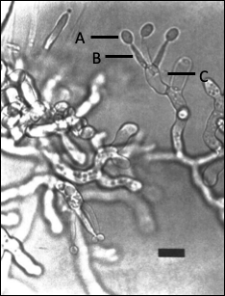
Figure 14.5. Thanatephorus cucumeris (R. solani) sexual structure showing basidiospores (A) attached to the sterigmata (B) which are produced on basidia (C) (Carling et al. 1987).

Other damping off fungi belong to the phylum Ascomycota in the genus Fusarium, Botrytis, and Macrophomina. Bloomberg in 1978 noted that temperature was the biggest environmental factor affecting disease incidence by damping off fungi. The biology of most of these fungi are found elsewhere throughout the book. It is important to note that species of both Botrytis and Marcophomina readily form sclerotia and may be a distinguishing identification factor for farmers or agronomists. Fusarium species can also produce chlamydospores as a resting structure to survive harsh environments for long periods of time.

Prevention & Treatment
Treatment of damping off depends on the disease organism, where it is (seed vs. soil), and also environmental conditions. As always, prevention is the number one way to deal with damping off disease. If planting seeds, there are various seed coat treatments that can be directly applied to seeds. Seed can be pretreated with organisms antagonistic to damping off, such as Trichoderma products (e.g. Rootshield WP) or surface sterilized with a dilute bleach solution or alcohol (Lifshitz et al. 1986, Wenny and Dumroese 1987).
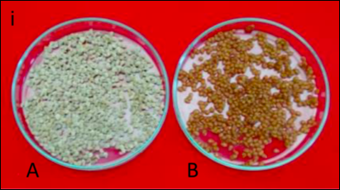
Figure 14.6. A) Untreated tomato seeds next to B) tomato seeds inoculated or ‘bioprimed’ with Trichoderma spp. Vivek et al. 2016.

The use of biocontrol agents (BCA’s in agriculture) is increasing in popularity due to the increased resistance to chemical pesticides and heightened concern of the potential damage some of the chemicals can have on soils and humans (Coninck et al. 2020). Many Trichoderma spp. BCA’s act as mycoparasites to some damping off organisms, thereby directly parasitizing the plant pathogen and also promoting plant growth promoting compounds (Bedine Boat et al. 2019).
Treatments can also be applied into the media prior to planting and become less effective and necessary as the seedling grows. When starting seed in pots, the media can be pasteurized to eliminate potential disease organisms (Warcup and Baker, 1963). Steam sterilization may also be used to treat large areas of soil on a field and greenhouse scale. Steam sterilization should actually be called pasteurization, as it does not kill all life in the soil. In fact specific temperature range and treatment times may kill pathogenic species while retaining beneficial organisms (Tanaka et al. 2003). Beneficial organisms may also be selectively inoculated into treated soil.
Alternating what crops are grown in the contaminated soil can also reduce the population of DO species, particularly if using Brassicas in the rotation and incorporating crop residue post harvest (Njoroge et al. 2009) (See Chapter 19 “Soil Treatments”.) If a crop is grown that the pathogen is unable to infect, it will have to compete solely as a saprophyte against many aggressive competitors. Rotating crops until there is no longer any sign of damping off may be one long-term method of removing these pathogens from a particular field (Cheah et al. 2008).
Avoid over-watering seedlings and do not allow seedlings to germinate in damp cool conditions. Adding a seedling heat mat indoors can resolve this issue. Outdoors, make sure you are far enough from the last frost in your area before direct sowing of seeds. Clean any equipment prior to use for seed planting and ensure you are planting into the healthiest soil you are capable of preparing. Having adequate airflow and temperature is always good practice when germinating seeds, reducing the chance of pathogen growth and stimulating plant growth. And, as always, make sure you are planting high quality genetics to ensure the greatest chance of success.

